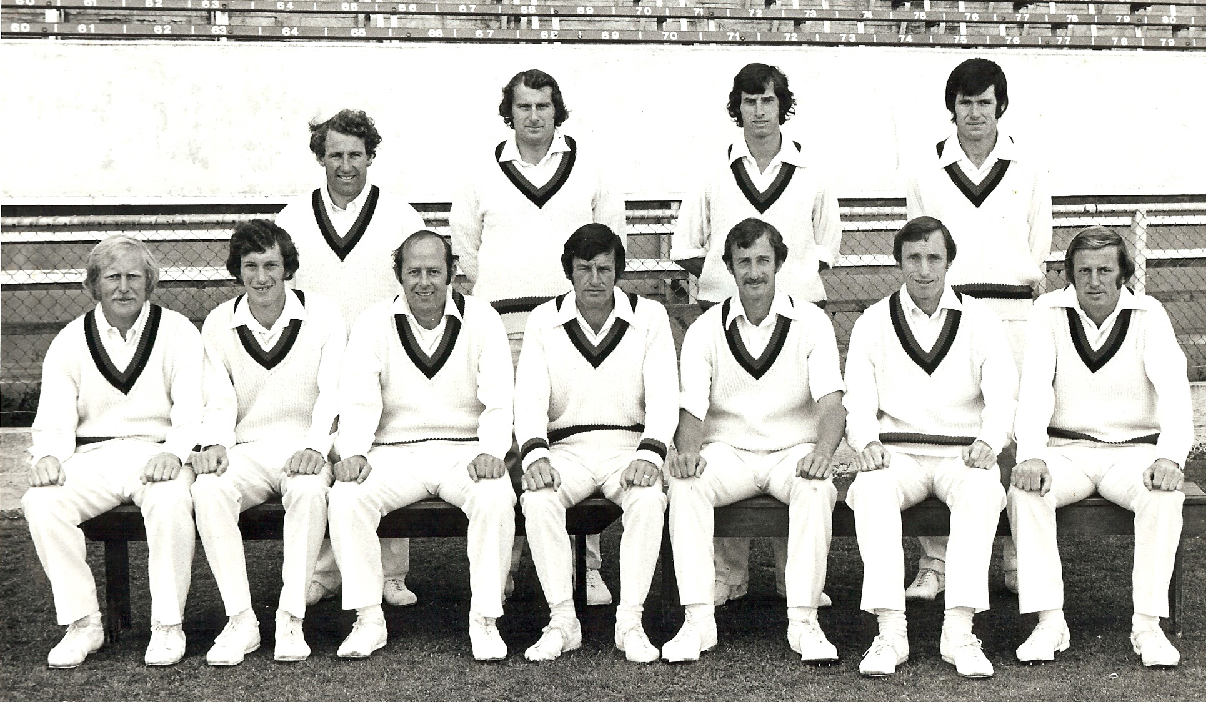

**Canterbury Representative Team 1975/76**

**Back row:** PG Coman, AR Hounsell, RJ Hadlee, NM Parker

**Front row:** KJ Wadsworth, SL Boock, BF Hastings, BE Congdon captain, DR Hadlee, BG Hadlee, DW Stead